This Tastes Like Cardboard 50pts Name: _________________________ Pd: ___
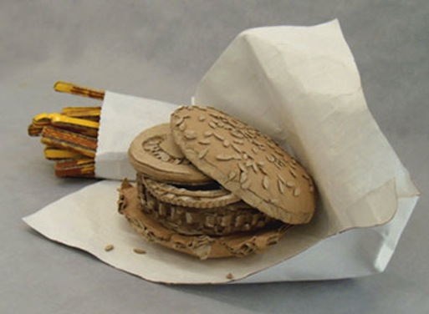
GOALS
Example: Burger for USA fast food epidemic.

Has a concept that relates to food culture
Has large, medium and small details
Realistic Texture & Form

Life often revolves around food and so do social issues. List as many different ideas behind food you can think of. Examples: Hunger, GMOs, Vegan, Cultural Food, Foodies, Gluten Free, Obesity…
1. 6. 11. 16.
2. 7. 12. 17.
3. 8. 13. 18.
4. 9. 14. 19.
5. 10. 15. 20.

Narrow your choices for a food to recreate out of cardboard. Circle your choice.
1. 3. 5.
2. 4. 6.

In your sketchbook draw a large detailed plan of your sculpture. Drawing should take up at least one whole page. Drawing should explain how each goal will be met, including how it relates to food culture.

This Tastes Like Cardboard 50pts Name: _________________________ Pd: ___
GOALS
Example: Burger for USA fast food epidemic.

Has a concept that relates to food culture
Has large, medium and small details
Realistic Texture & Form

Life often revolves around food and so do social issues. List as many different ideas behind food you can think of. Examples: Hunger, GMOs, Vegan, Cultural Food, Foodies, Gluten Free, Obesity…
1. 6. 11. 16.
2. 7. 12. 17.
3. 8. 13. 18.
4. 9. 14. 19.
5. 10. 15. 20.

Narrow your choices for a food to recreate out of cardboard. Circle your choice.
1. 3. 5.
2. 4. 6.

In your sketchbook draw a large detailed plan of your sculpture. Drawing should take up at least one whole page. Drawing should explain how each goal will be met, including how it relates to food culture.

