Surrealist Sculpture 50 points
Name: _________________________ Pd: ___
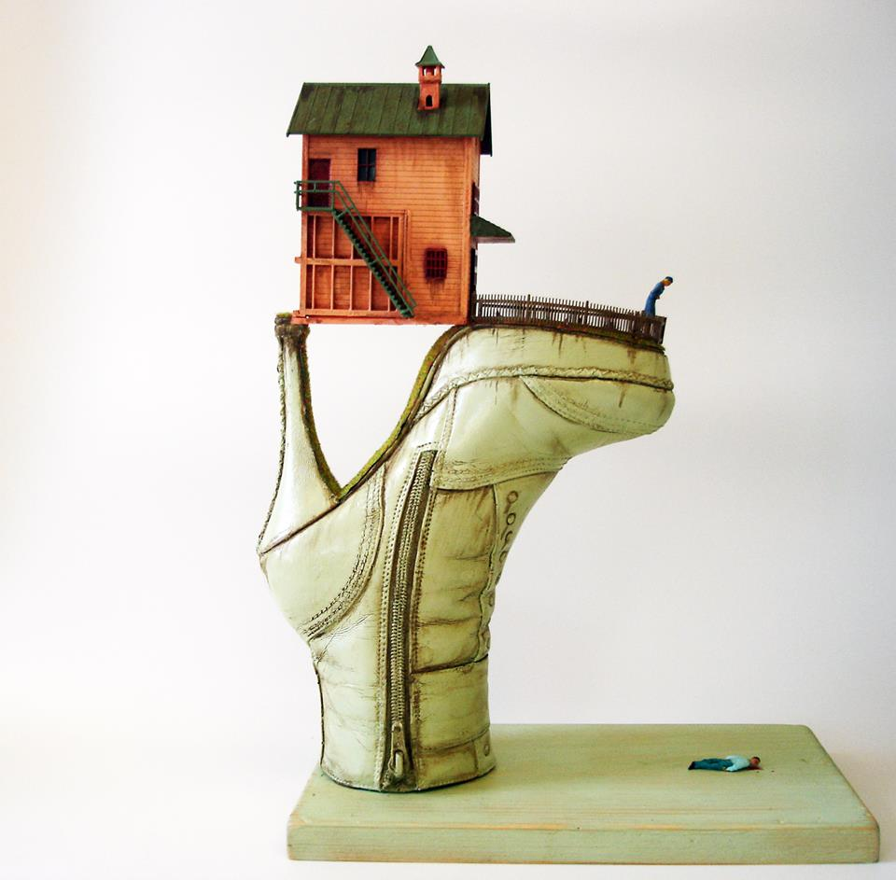
GOALS
*Realistic Color and Details
I recommend clay for this project, but any material used in class is a viable option.
*Two ideas combined into one
*Stands on it’s own
*Is non functional
*Concept choice explained on grading rubric
Surreal: Is dreamlike, real yet unreal, irrational and an attempt to release the creative potential of the unconscious. Coming up with your idea for this project might take some time. Below, Mindmap out any dream (or random idea) you can remember. If you’re having trouble coming up with an idea, use a shoe as one part of your idea or create a visual pun.

Dreams

From your mindmap chose 2 ideas to combine into your sculpture.

In your sketchbook: draw a large, detailed picture of the sculpture you plan to make. This drawing should be the plan for your project.

