Slab Mug Planning Sheet Name:_____________________ Pd:__
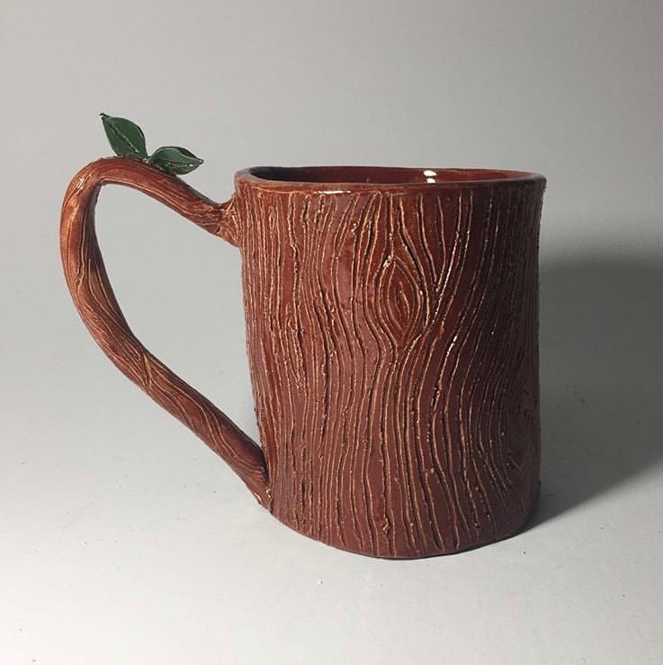
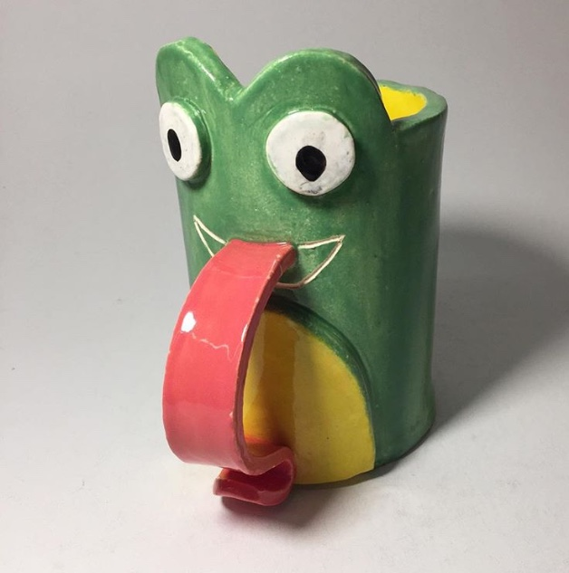
GOALS:
- Has a handle
- Is built using the slab technique
- Includes a pressed in texture from home
- Represents your idea of Home

- Create a list of words that you think of when you hear/see the word home?

- What item will you bring in to create a texture that depicts your ideas of home?

WHERE I’M FROM POEM:
I am from ________________________________________ (specific ordinary item), from __________________________ (product name) and _____________________________.
I am from the ____________________ (home description... adjective, adjective, sensory detail).
I am from the ____________________________________ (plant, flower, natural item), the ________________________________________________ (plant, flower, natural detail)
I am from __________________ (family tradition) and _______________ (family trait), from ________________________ (name of family member) and _______________________ (another family name) and _______________________________________ (family name).
I am from the _____________ (description of family tendency) and ___________ (another one).
From _______________ (something you were told as a child) and ______________ (another).
I am from____________________ (representation of religion, or lack of it). Further description.
I'm from ______________________________________ (place of birth and family ancestry), ________________________________________ (two food items representing your family).
From the ______________ (specific family story about a specific person and detail), the _______ (another detail, and the _____________________ (another detail about another family member).
I am from ____________________________________________________________ (location of family pictures, mementos, archives and several more lines indicating their worth).
SKETCHBOOK: In your Sketchbook draw 5 potential shapes for your mug. Draw 5 options of handles for your mug. Draw 1 large detailed plan of your final mug project.

PRACTICE MUG:: You should create at least 2 completed mugs. The first mug is your practice mug. This mug you may use the Washington state cookie cutter if you wish and does not need to have a texture. The second mug should be your final. You will probably make more mugs than that because it is difficult and you will probably need to start over multiple times!

