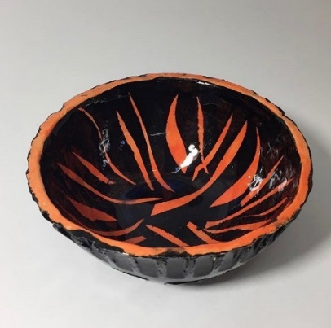
Clay Bowl- Exploring Clay and Glaze Techniques 50 points
There are a vast number of clay and glazing techniques out there. Research a technique you have never tried and create a bowl. Look through the in class packets, or research your own idea online. You may create the bowl base via, slab, coil or potter’s wheel. *Tip* Try to make more than one bowl 3rd times a charm!*
Goals:
*Uses one of the info packet techniques or research your own
*Written directions on how to achieve technique
*Project is fired and glazed according to technique
*Full name on bottom of Bowl
*Is a new technique you have never used

Check off idea with Ms. Mann

Planning out your project:
Which technique did you choose?
How will you construct your bowl? Circle one: Slab coil potter’s wheel
Does your project need to be bisque or leather hard for your technique to work?
Why?

What questions do you have about your technique?

Simplified Directions for your chosen technique:

