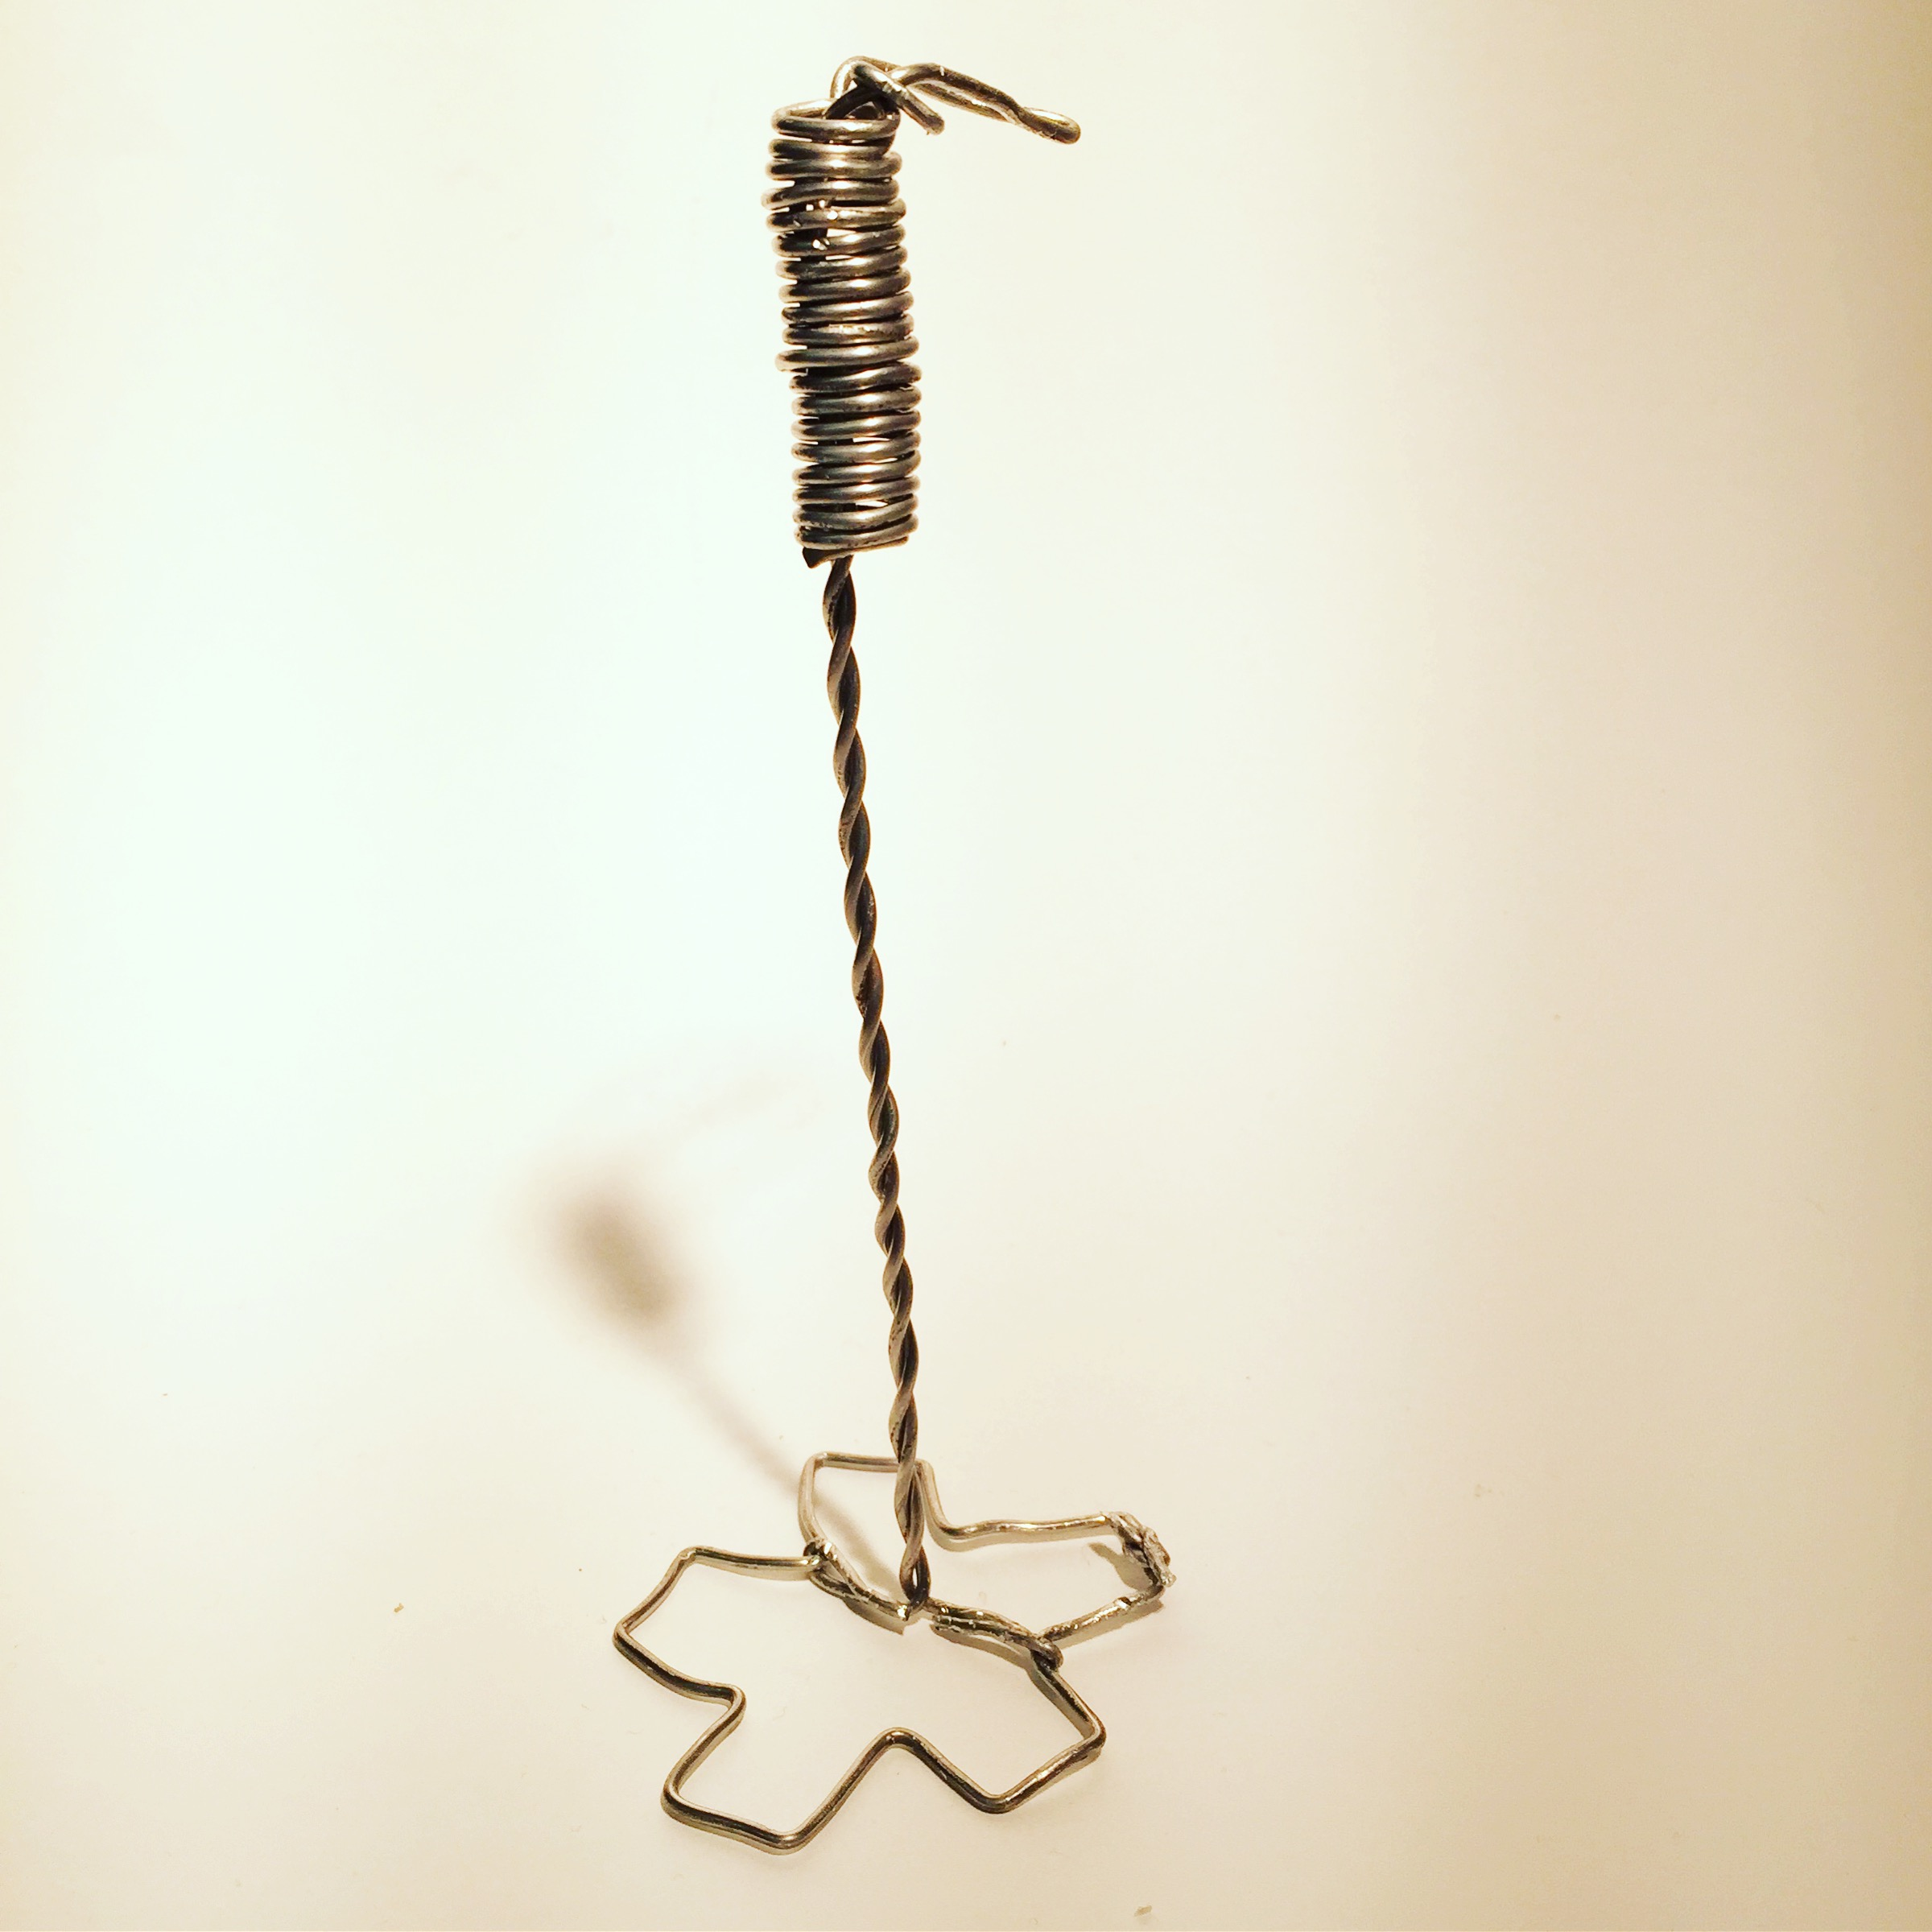
Wire Sculpture Name: ________________________ Pd:____
Create a sculpture out of wire which represents something unique about yourself.
Project Goals:
Variation of line weight (thick, medium, thin)
Represents unique attribute
Uses more than one technique

Define the art terms:
LINE:_____________________________________________________________________________________
VARIATION:_____________________________________________________________________________
LINE WEIGHT:__________________________________________________________________________

Questions to answer:
- What are some unique aspects about me?

- How could I represent this using wire?

- Will you incorporate color? Where?

Sketchbook: Draw 3 smaller possible projects you could make to represent yourself. Draw one large detailed drawing of your favorite smaller sketch. Include where you will have Size variation.

Wire Sculpture Name: ________________________ Pd:____
Create a sculpture out of wire which represents something unique about yourself.
Project Goals:
Variation of line weight (thick, medium, thin)
Represents unique attribute
Uses more than one technique

Define the art terms:
LINE:_____________________________________________________________________________________
VARIATION:_____________________________________________________________________________
LINE WEIGHT:__________________________________________________________________________

Questions to answer:
- What are some unique aspects about me?

- How could I represent this using wire?

- Will you incorporate color? Where?

Sketchbook: Draw 3 smaller possible projects you could make to represent yourself. Draw one large detailed drawing of your favorite smaller sketch. Include where you will have Size variation.

WIRE GRADING RUBRIC – SCULPTURE 1
YOUR NAME: _______________________________TITLE: ______________________________PERIOD: _____
 | Advanced | Proficient | Basic | In-progress
Goals: Write in goals  9-10  7-8  3-6  1-2 | *Variation of line weight (Thick, medium, thin)  *Represents unique attribute (less than 25 students at Skyline)  *Uses more than one technique. | Missing 1 goal  Or all goals need a little more attention  Project stands on it’s own. | Missing 2 or more goals  Project barely stands. | Goals need to be addressed.  Project doesn’t stand on it’s own.
Creativity:  9-10  7-8  3-6  1-2 | Project has never been seen. It is detailed, pushes the concept of the project. Did something different or new with wire. | Idea is more creative than most students’ but could still push idea more. Sports-themed | Chose to copy idea from teacher examples or Power point. This idea is cliché, basic, seen often, is holiday art, sponge bob etc. | Copied off of the internet (plagiarism)
Challenge:  5  4-3  2  1 | Chose most difficult options. Spent extra time revising. Many tries to get it right. Used all class time. | Chose normal level of difficulty and typical amount of work. Did requirement of project. | Cut corners, finished early when revisions should be done. Project looks rushed. | Did bare minimum required of the project. Little effort put forth.
Craftsmanship:  9-10  7-8  3-6  1-2 | Techniques executed well, clean, emphasis used for color. High level of details, multiple techniques used, wire is smooth. Attachments clean. Clearly resembles idea | Some small sections need more work, a few attachment areas need cleaning up. Some small areas to straighten or smooth the wire. | Wire has been ‘chewed’ up by pliers. Attachment points are clumsy. Not many techniques are used. Has a wire base for it to stand. Hard to tell what the project is | Project is falling apart or loose pieces are falling off. Cannot stand on it’s own.
Work ethic:  9-10  7-8  3-6  1-2 | Respectful of all routines, procedures people, tools and materials. Cleans up own area and keeps community areas clean. Helps others. | Occasional mess. Finish project early instead of revising.  Needs to improve listening and reading the board. | Cleaned up early and not helping others.  Leaves mess, often not working. Leaving projects incorrect place or cart. Not in assigned seat. | Seen using phone (after clean up counts) Phone not in backpack entire time  Tardy often  Disrespect of tools and others  Project found as ‘litter’ in school.
Artist Statement:  Fill out on back!  5  4-3  2  1 | Complete sentences used and all questions are answered. Insightful reflections written. | Some incomplete sentences used.  But all questions are answered.  Vague answers | One word responses  to questions.  or not all questions are answered. | Student didn’t self-grade  Artist statement left blank.
Grade yourself
________/50

Grade ______/50
Comments to consider:

WIRE SCULPTURE GRADING RUBRIC – SCULPTURE 1
ARTIST STATEMENT

- What is your idea behind this project?

- How did you achieve the goals?

- What do you want the viewer to think about?

- What did you change during the process of making this?

- What would you do differently next time?

Wire Sculpture Checklist

Watch presentation about project

Fill out answers to planning sheet

Draw ideas in sketchbook

Bring sketchbook and planning to Ms. Mann to see

Get Wire, pliers and technique sheet.

Start creating wire

Grade yourself with the grading rubric

Turn in sculpture with grading rubric

