- Variation Coil Pot 50 points Name: _______________________ Pd: __
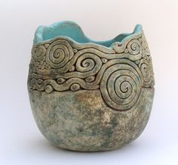
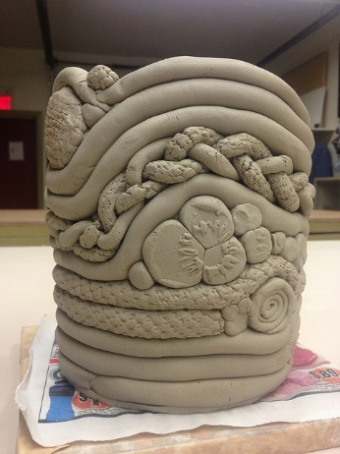

GOALS
* 3 different variations of coils
* 6 inches tall
* Nothing falls off (score and slip!)
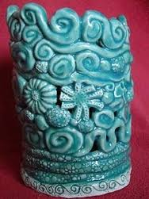
*All bisqueware glazed except base.

GREENWARE: _________________________________________________
______________________________________________________________
RHYTHM:______________________________________________________
______________________________________________________________

I can make a coil by:___________________________________________________________
________________________________________________________________________________
I can score and slip by:_________________________________________________________
________________________________________________________________________________________________________________________________________________________________
Sketchbook: Sketch out 5 creative coils. Draw one large detailed drawing of your plan.

- Variation Coil Pot 50 points Name: _______________________ Pd: __

GOALS
* 3 different variations of coils
* 6 inches tall
* Nothing falls off (score and slip!)
*All bisqueware glazed except base.

GREENWARE: _________________________________________________
______________________________________________________________
RHYTHM:______________________________________________________
______________________________________________________________

I can make a coil by:___________________________________________________________
________________________________________________________________________________
I can score and slip by:_________________________________________________________
________________________________________________________________________________________________________________________________________________________________
Sketchbook: Sketch out 5 creative coils. Draw one large detailed drawing of your plan.

GRADING RUBRIC 3 Variation COIL POT – SCULPTURE 1
YOUR NAME: ________________________________ PrOJECT: _______________________________PERIOD: _____
 | Advanced | Proficient | Basic | In-progress
Goals:  9-10  7-8  3-6  1-2 | *6” tall  *3 different coil types  *All bisqueware glazed except base  *No pieces fall off | Missing 1 goal  Or all goals need a little more attention | Missing 2 or more goals | Goals need to be addressed.  Project blew up.
Creativity:  9-10  7-8  3-6  1-2 | New coils invented. Has many different coils, is not a cylinder, glaze goes well with design. Uses patterns and/or rhythm. | Idea is more creative than most students’ but could still push idea more. Has one unique coil, some uniqueness to form. | Chose to copy idea from teacher examples.  Has many spiral, plain, braid, or dots. | Copied off of the internet (plagiarism)
Challenge:  5  4-3  2  1 | Chose more difficult options. Spent extra time revising. Many tries to get it right. Used all class time. Extra height. | Chose normal level of difficulty and typical amount of work. Did requirement of project. | Should smooth and revise more. Project looks rushed. Cheats height by leaving large gaps. Mostly plain coils | Very little effort put forth. Project is short with many plain coils.
Craftsmanship:  9-10  7-8  3-6  1-2 | Techniques executed well, clean, solid color, textures, high level of details, multiple techniques used. Smoothed, even coils, all bisqueware evenly glazed. | Some small sections need more smoothing, glaze needs more layers. Just a few spots missing glaze. Rough surface texture. Coils could be more even. | Has many score marks showing. Uneven coil thickness. Glaze needs more practice. Form is warped or wobbly. Has glaze on the bottom. Many spots missing glaze. | Project is falling apart or loose pieces are falling off. Glaze is sloppy. Project blew up in Kiln.  Didn’t write name on bottom.
Work ethic:  9-10  7-8  3-6  1-2 | Respectful of all routines, procedures people, tools and materials. Cleans up own area and keeps community areas clean. Helps others. | Occasional mess. Finish project early instead of revising.  Needs to improve listening and reading the board. | Cleaned up early and not helping others. Standing around.  Leaves mess, often not working. Leaving projects incorrect place or card. | Seen using phone (after clean up counts) Phone not in backpack entire time Tardy often  Disrespect of tools and others Project found as ‘litter’ in school.
Artist Statement:  Fill out on back!  5  4-3  2  1 | Complete sentences used and all questions are answered. Insightful reflections written. | Some incomplete sentences used.  But all questions are answered.  Vague answers | One word responses  to questions.  or not all questions are answered. | Student didn’t self grade  Artist statement left blank.
Grade yourself  ________/50  Grade ______/50 |  |  |  | Project is late -5  You have 1 week after the due date before the project is considered late.
Comments to consider:

GRADING RUBRIC – SCULPTURE 1
ARTIST STATEMENT

- What is your idea behind this project?

- How did you achieve the goals?

- What do you want the viewer to think about?

- What did you change during the process of making this?

- What would you do differently next time?

