SCULPTURE 2 Name:___________________________ Pd:____
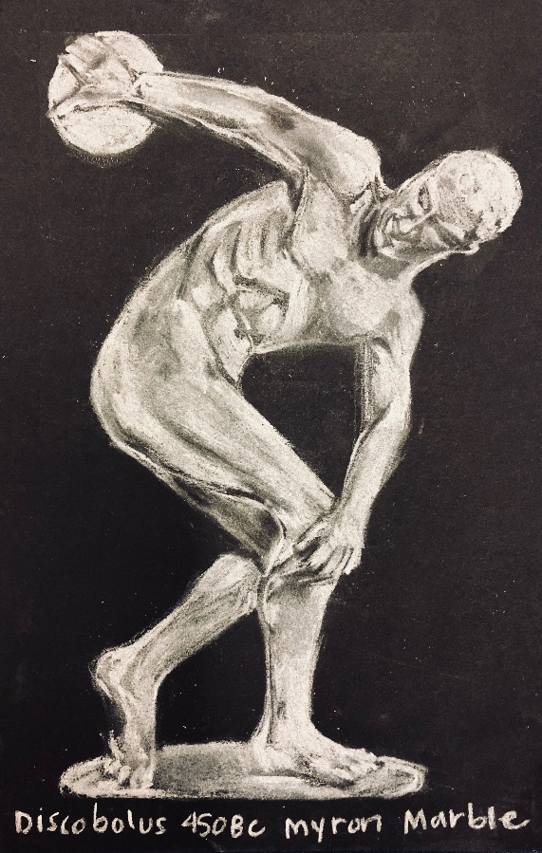
Reverse Postcard Planning 20pts
Using black cardstock and white pencils, create a postcard of a sculpture. Must include the title, artist, medium and year. If you are struggling you may use an off white cardstock and graphite pencil.
Resources to help you find a sculpture to draw
https://www.nga.gov/Collection/sculpture/sculptures-grid.html
https://www.google.com/culturalinstitute/beta/category/medium
https://walkerart.org/collections/browse?page=1&type=sculptures
https://collections.artsmia.org/search/sculpture
https://www.guggenheim.org/artwork/artwork_type/sculpture
https://www.louvre.fr/en/moteur-de-recherche-oeuvres?f_search_art=sculpture
Source (write what website you got your image from)

Title:__________________
Artist:__________________
Year:__________________
Medium:_______________
*You need to print out your image to work from and GLUE into Sketchbook. SHOW PLANNING SHEET COMPLETED IN SKETCHBOOK*
- - - - - - - - - - - - - - - - - - - - - - - - - - - - - - - - - - - - - - - - - - - - - - - - - - - - - - - - - - - - - - - - - - - - - - - - - - - - - - - -

Postcard Grading Rubric
Please circle the score you believe you have earned
20 - Carefully completed drawing of a sculpture, has title, artist and date, tape cleanly removed. Planning sheet and image is in sketchbook with checked off by Teacher.
18 - Completed drawing of a sculpture but could use more revision. Sketchbook incomplete.
15 - Drawing is not complete, gridlines show, no artwork information no planning sheet, tape still on, project is late.
- - Drawing is not a sculpture, not complete, no information, postcard is turned in late.
0 -Postcard has not been turned in.

