Name:_________________________ Pd: __

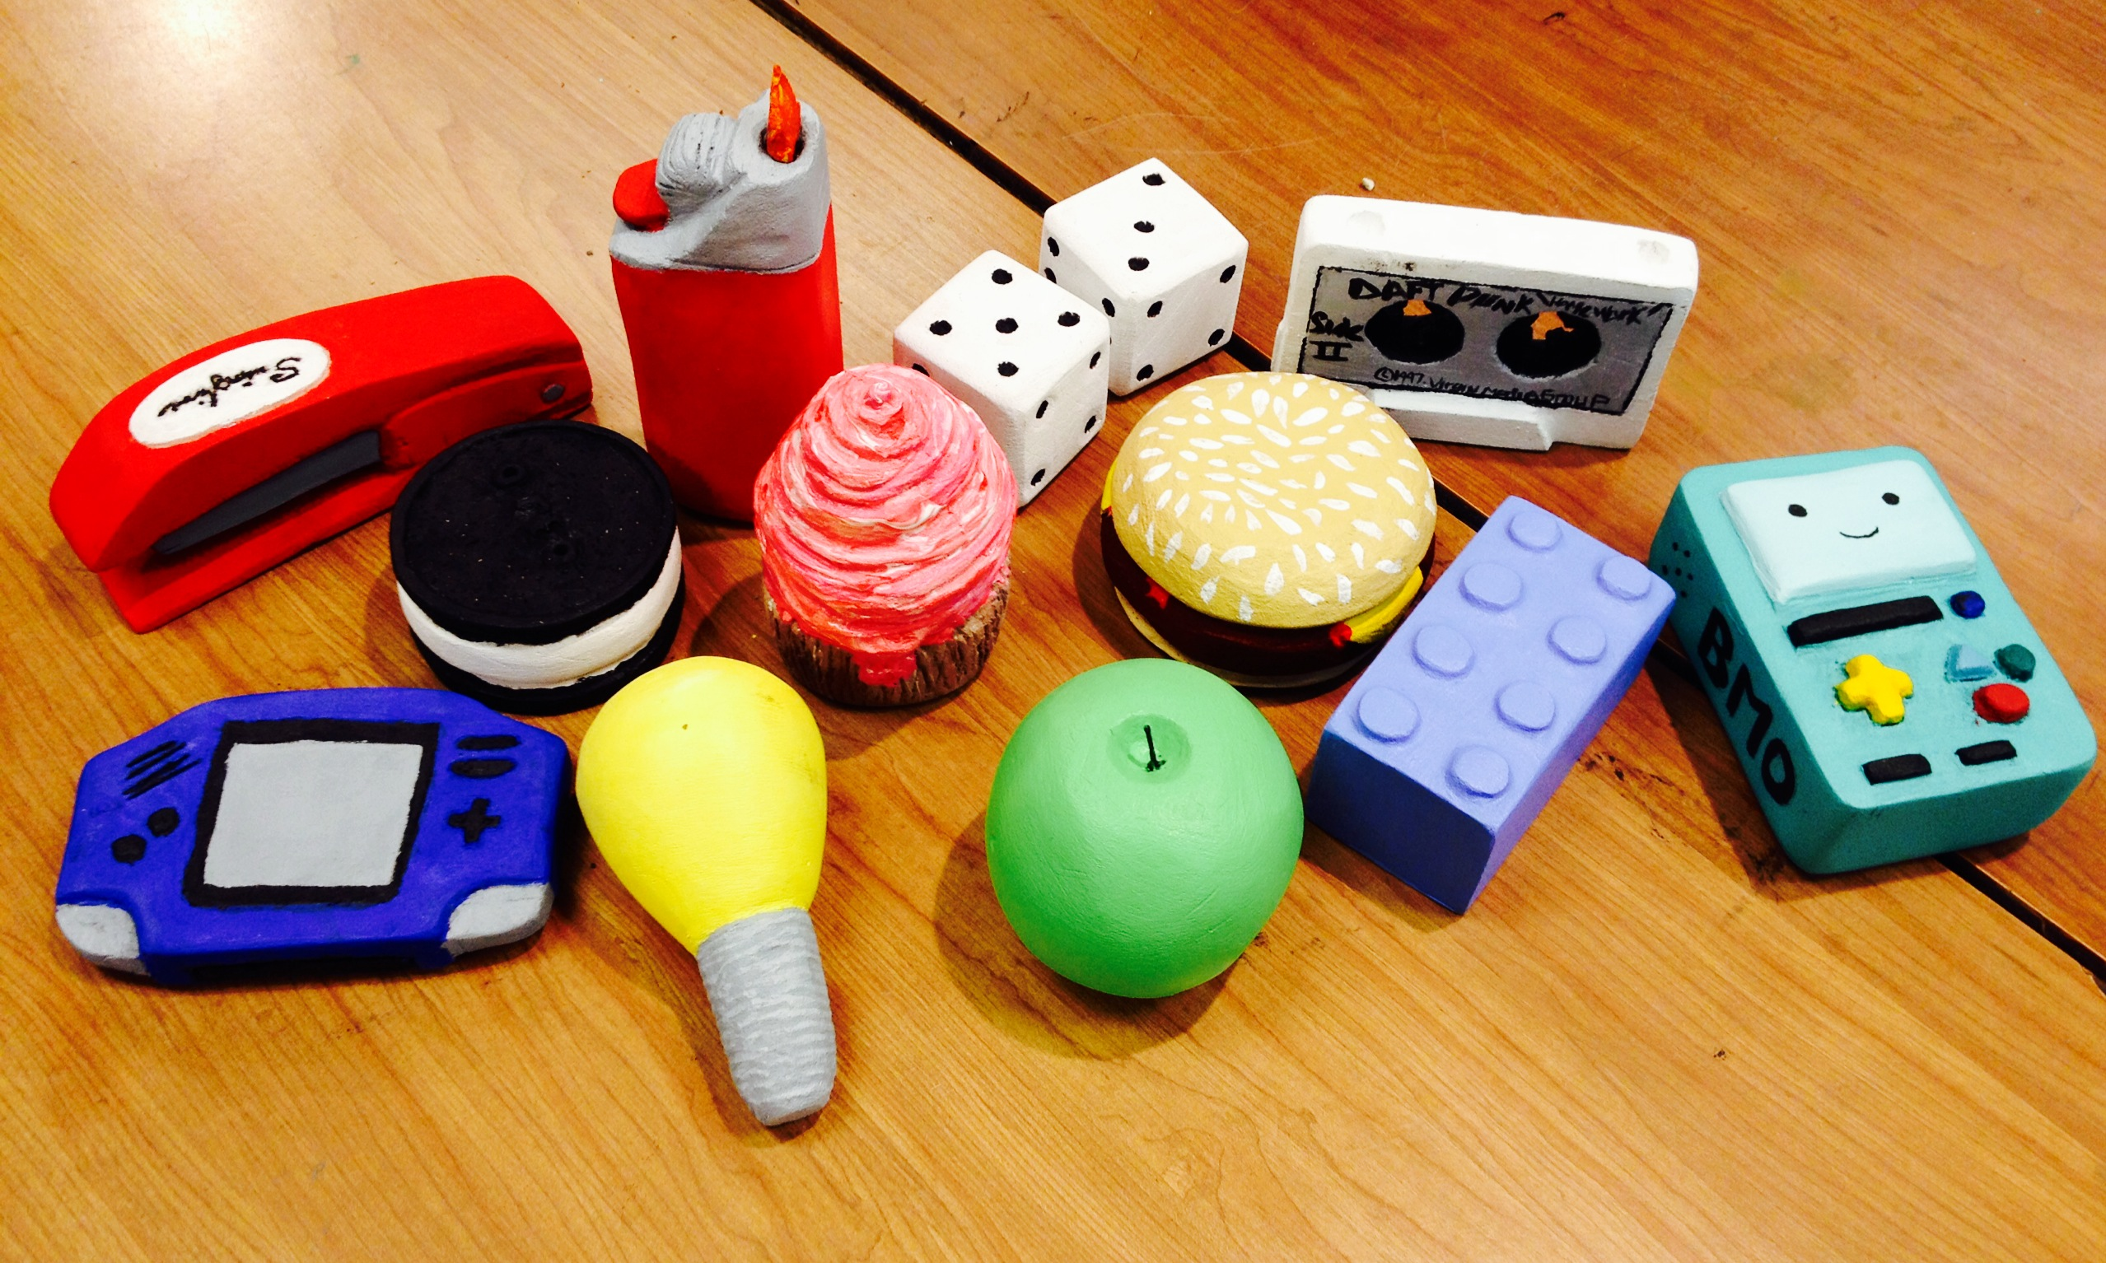
Pop Art Foam Block Carving 50 points (Planning Sheet = 5 points)
Goals :
*Realistic Color
*Accurate form
*Very detailed
*3D not flat/2D

Below list 20 items from pop culture, thing of things from movies, shows, celebrities, musicians etc
* * * *
* * * *
* * * *
* * * *
* * * *
Narrow down your choices and list 5 possible objects you could create. Try to choose something unique and special to your own interests.
* * *
* *

Research what your object looks like. Below, draw out your chosen object, from 3 different viewpoints.

Below mix and paint the realistic colors you plan to use for your object.

x

Name:_____________________________ Pd:___
Using only the primary colors (red, blue, yellow) mix and fill in the different sections.
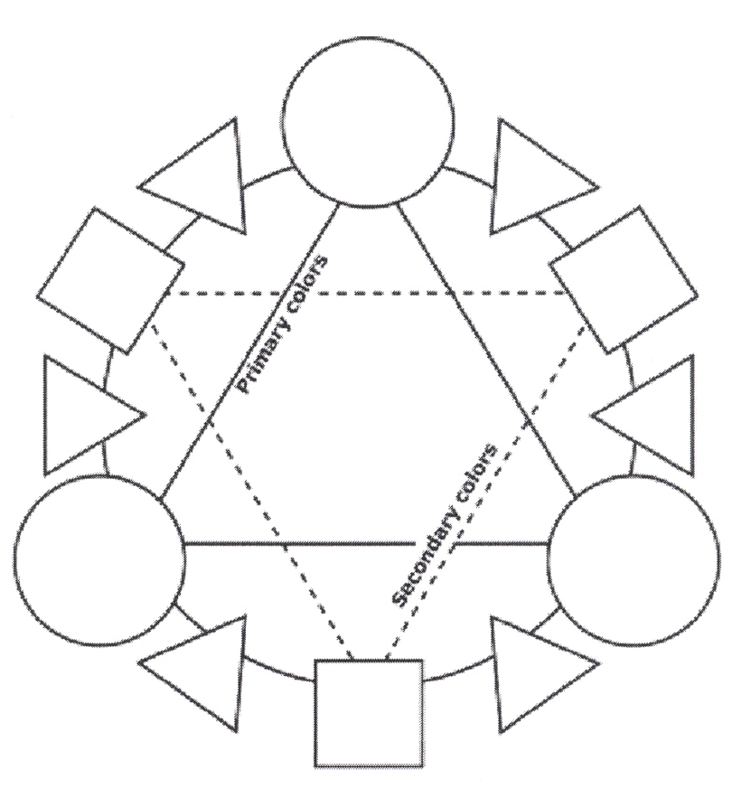

Mix Black by making a deep blue/purple and add small amounts of yellow until black.

Mix Brown by using a base of red, adding small amounts of blue and yellow until brown. OR mix two complementary colors.

Complementary: Paint the 3 main sets. Complementary colors are across from one another on the color wheel.

Monochromatic. Choose one color and in each increment add more white until you have pure white at the other end.

Pop Art

Foam Block Carving

1.1.6 Creates, analyzes, and evaluates the element color when producing a work of art.
4.3 Understands how the arts impact and reflect personal choices throughout life.
Analyzes how an individual’s choice of clothing reflects the popular culture of the time as well as social and environmental influences

