Wearable Masks- Planning Sheet Name: _________________________ Pd: ___
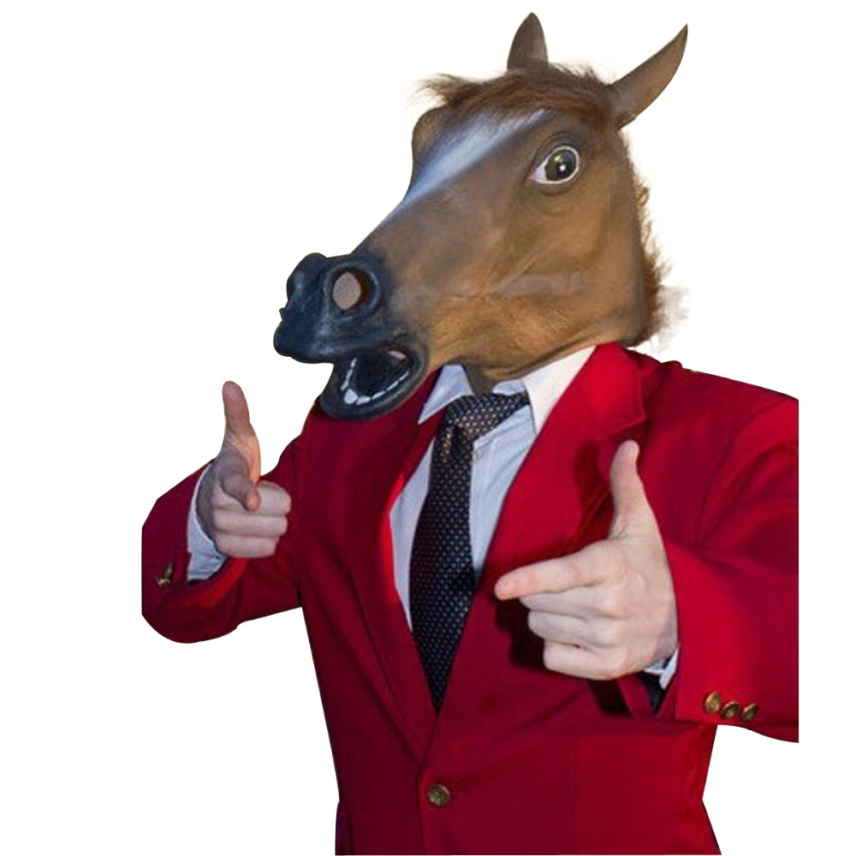
GOALS:
*Mask can be worn
*Is mixed-media (more than 3 materials used)
*Has 3D elements in at least 3
*Has balance- Symmetrical or asymmetrical
*Concept: Personal or Cultural

BALANCE: _____________________________________________________________________________________________
ASYMMETRY:__________________________________________________________________________________________
SYMMETRY:____________________________________________________________________________________________
MIXED-MEDIA:________________________________________________________________________________________

Cultural Concepts Personal Concepts
1. 1.
2. 2.
3. 3.
4. 4.
5. 5.

Explain your concept of Cultural or Personal?

List all materials you plan to use:

Are there any special materials you will need?

Ask a neighbor for one suggestion based off of your plan and write it below:

SKETCHBOOK.

In your sketchbook: draw a full page, detailed plan of the mask you plan to make that shows your mask captures all the project goals.
WEARABLE MASKS GRADING RUBRIC – SCULPTURE 2
YOUR NAME: ________________________________ PrOJECT: _______________________________PERIOD: _____
 | Advanced | Proficient | Basic | In-progress
Goals: Write in goals  5  4-3  2  1 | *Mask is wearable  *Mixed-media (3+ materials used)  *Has 3x 3D elements  *Has balance  *Concept: personal or cultural | Missing 1 goal  Or all goals need a little more attention | Missing 2 or more goals | Goals need to be addressed.  Project cannot be worn, or has no string
Creativity:  9-10  7-8  3-6  1-2 | Project has never been seen. It is very detailed, pushed the concept of the project. Did something different or new with materials. | Idea is more creative than most students’ but could still push idea more. Not sure of concept or how it works with culture | Chose to copy idea from teacher examples or Power point. This idea is cliché, basic, seen often, Mardi gras mask, day of the dead mask, marvel, Disney- other cliches | Copied off of the internet (plagiarism)
Challenge:  5  4-3  2  1 | Chose most difficult options. Spent extra time revising. Many tries to get it right. Used all class time. | Chose normal level of difficulty and typical amount of work. Did requirement of project. | Cut corners, finished early when revisions should be done. Project looks rushed. | Did bare minimum required of the project. Little effort put forth. Just glued pieces on instead of building.
Craftsmanship:  9-10  7-8  3-6  1-2 | Techniques executed well, clean, solid color, textures, high level of details, multiple techniques used. | Some small sections need more work. Clean up paint/glaze edges. Rough surface texture. Not very many techniques used | Lacking detail/ texture, unfinished sections. Paint lines very messy, glue or tape is showing, cracking, form is warped or lumpy | Project is falling apart or loose pieces are falling off. Paint is sloppy. Project blew up in Kiln.
Work ethic:  9-10  7-8  3-6  1-2 | Respectful of all routines, procedures people, tools and materials. Cleans up own area and keeps community areas clean. Helps others. | Occasional mess Finish project early instead of revising.  Needs to improve listening and reading the board. No name on project. | Cleaned up early and not helping others. Sitting doing nothing. Chatting with others and not working.  Leaves mess. Leaving projects incorrect place or card. | Seen using phone (after clean up counts) Phone not in backpack entire time  Tardy often  Disrespect of tools and others  Project found as ‘litter’ in school.
Artist Statement:  Typed and printed  9-10  7-8  3-6  1-2 | Complete sentences used and all questions are answered. Insightful reflections written. | Some incomplete sentences used.  But all questions are answered.  A couple vague answers | One word responses  to questions.  or not all questions are answered. Many vague responses. | Student didn’t self grade  Artist not turned in or is difficult to read.
Grade yourself
________/50

Grade ______/50
Comments to consider:

