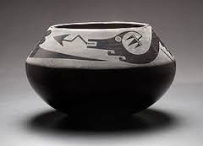
Maria Martinez Article Questions Name: ___________________ Pd:__

1.What did Maria Martinez do in order to continue her art due to the decline?
2.How did Maria Martinez learn pottery?
3.What is the process for making this type of pottery?
4.Why did Martinez sign her name on pottery made by others?
5.Why is Maria Martinez so famous?
6.What are you going to bring from learning about this artist into your own project?
7.What was something surprising you learned from the article?
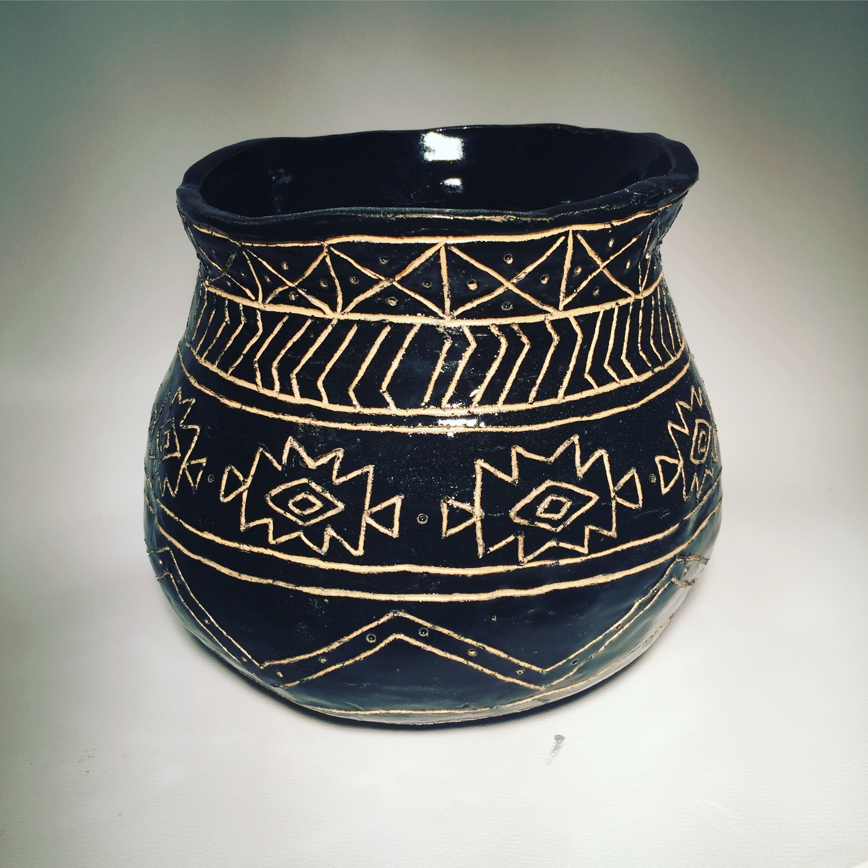
Maria Martinez Planning Sheet
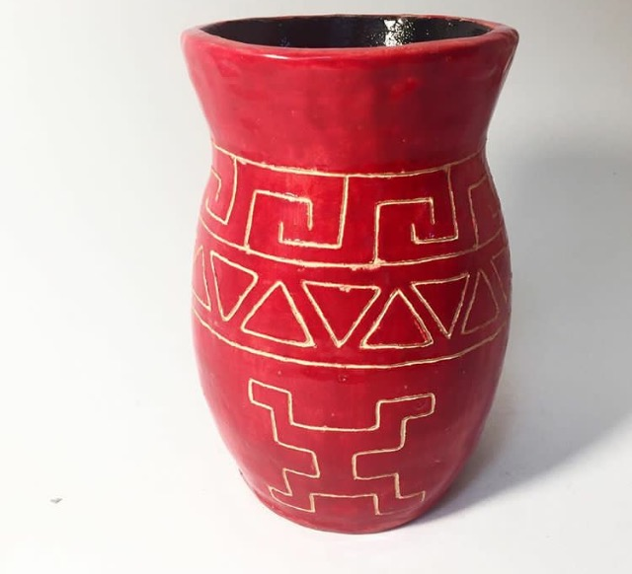
Goals:

*3patterns/designs from your identity/culture
*All coils are smoothed (including interior)
*Project has a shape other than cylinder
*Project is at least 6” tall

SKETCHBOOK WORK:

1. Research patterns and designs from your own culture(s) and sketch at least 3 in sketchbook. it helps if you can simplify the pattern)

2. In sketchbook draw out 5 different possible shapes/forms for your project, *any shape that is not a cylinder.

3. Create one large drawing combing your favorite shape with your cultural patterns. This is the plan for your final project.

