Name: _________________________ Pd: ___
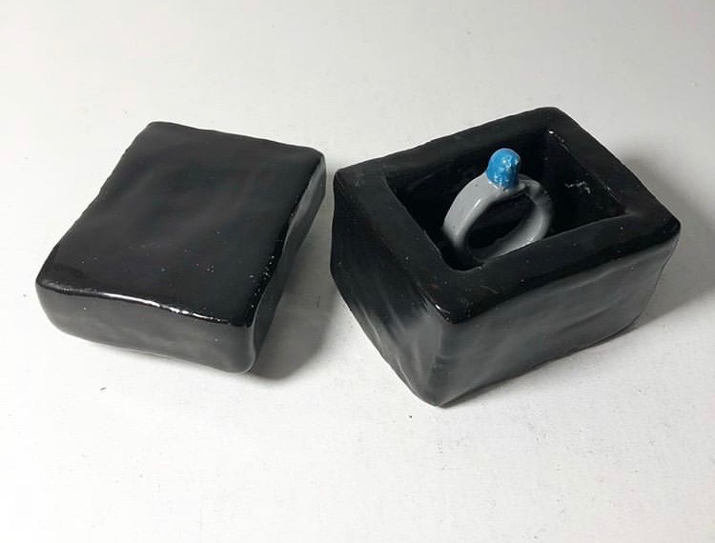
Functional for a Public Figure Planning Sheet

GOALS
Project clearly related to public figure
Glazing is clean and solid
Is detailed and includes a texture
Is functional (be creative! No mugs or vases!)

List as many functional ceramic objects you can. Circle your choice.
1. 6. 11. 16.
2. 7. 12. 17.
3. 8. 13. 18.
4. 9. 14. 19.
5. 10. 15. 20.

Brainstorm Potential Public Figures. Circle your choice.
1. 3. 5.
2. 4. 6.

Circle the clay technique(s) that would work best for this project..

PINCH POT COIL SLAB WHEEL THROWN

In your SKETCHBOOK draw a large final plan for your project.

Name: _________________________ Pd: ___
Functional for a Public Figure Planning Sheet

GOALS
Project clearly related to public figure
Glazing is clean and solid
Is detailed and includes a texture
Is functional (be creative! No mugs or vases!)

List as many functional ceramic objects you can. Circle your choice.
1. 6. 11. 16.
2. 7. 12. 17.
3. 8. 13. 18.
4. 9. 14. 19.
5. 10. 15. 20.

Brainstorm Potential Public Figures. Circle your choice.
1. 3. 5.
2. 4. 6.

Circle the clay technique(s) that would work best for this project..

PINCH POT COIL SLAB WHEEL THROWN

In your SKETCHBOOK draw a large final plan for your project.

