Ceramic Textured Vase- Planning sheet
Name: _________________________ Pd: ___
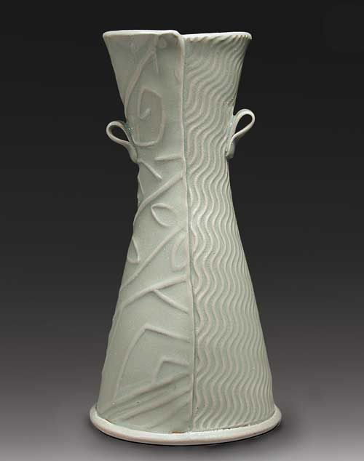
GOALS
6-8” Tall no exceeding 10”
Texture created by a non-art tool (you bring this in)
Rhythm is achieved with your texture
Glaze is solid and texture shows through
For this project choose the method you will use. This example was made by slabs.

Coil Wheel-Thrown Slab Combination

Texture: Brainstorm different textures you could use for your project.
1. 6.
2. 7. What texture do you plan to bring in? _______________
3. 8.
4. 9.
5. 10.

SKETCHBOOK: Draw a full page vase with your Texture, and Rhythm planned out.

Ceramic Textured Vase- Planning sheet
Name: _________________________ Pd: ___
GOALS
6-8” Tall no exceeding 10”
Texture created by a non-art tool (you bring this in)
Rhythm is achieved with your texture
Glaze is solid and texture shows through
For this project choose the method you will use. This example was made by slabs.

Coil Wheel-Thrown Slab Combination

Texture: Brainstorm different textures you could use for your project.
1. 6.
2. 7. What texture do you plan to bring in? _______________
3. 8.
4. 9.
5. 10.

SKETCHBOOK: Draw a full page vase with your Texture, and Rhythm planned out.

