http://weburbanist.com/2008/11/28/cardboard-art-and-sculptures/

Out-of-the-Box Sculptures: 5 Amazing Cardboard Artists
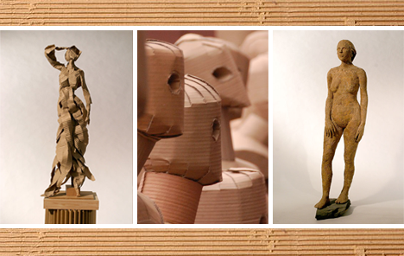
Who doesn’t love art that breaks the mold? Recycled art and design, green art and extraordinary art from everyday objects all stimulate the imagination in ways ordinary works can rarely achieve – and cardboard art is no exception. Recycled and environment friendly, the following artwork is not just an expression of the artists’ points of view but is also a statement about the nature of art itself.

Alex Uribe
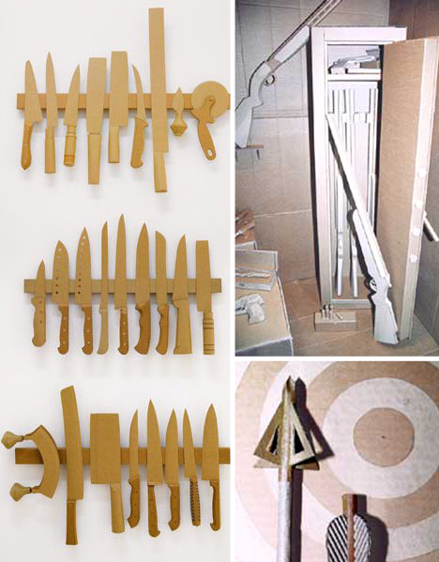
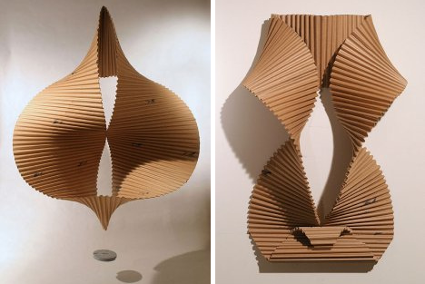
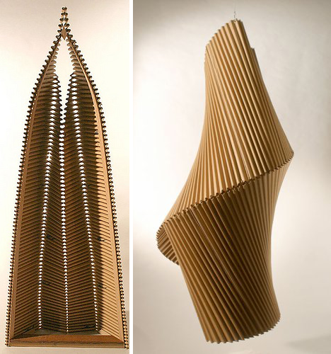
Inspired by nature, Alex Uribe creates sculptures exclusively from recycled, corrugated cardboard, both in large and small scale. Featured here are Uribe’s figurative, organic shapes, exploring abstract ideas rather than realism. Just as interesting are Uribe’s exposition of the female form as seen in Koura, Lucia, and Jodi.
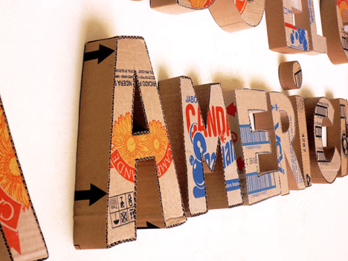

Sylvie Reno

Forty Kalashnikovs in 15 days, by hand, would be a daunting task for most people. She is not afraid, or angry, or bitter, for Sylvie Reno it’s just another day in her studio. She does, however, find relief in her compulsion and obsession with installations consisting mostly of repetitive work. Dozens of Kalashnikovs, a handful of automatic pistols, and more knives than Dexter will ever need, she says she has no imagination, we think she’s not being entirely honest.

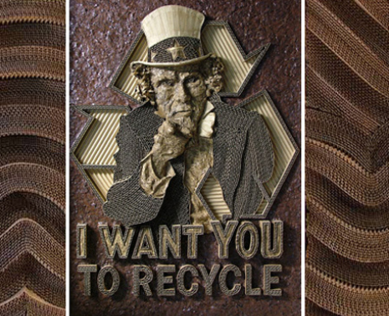
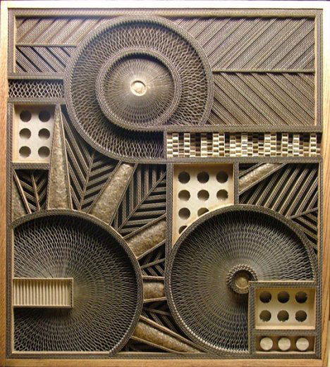
Mark Langan

(sources: Mark Langan, Inhabitat)
Looking at the beautifully complex pieces above, we would never have guessed that Langan’s exposure to corrugated cardboard art was purely accidental. Tearing apart some old cardboard boxes, Langan saw the beautifully corrugated innards of the boxes and thought to himself, “…if I were to slice, stack, and glue pieces to each other, some very interesting effects could be created.” With over 15 finished works (and counting) and the seemingly impossible intricacy of his work, there is no wonder he is one of the most popular and well-respected artists of his type.

Dag Weiser
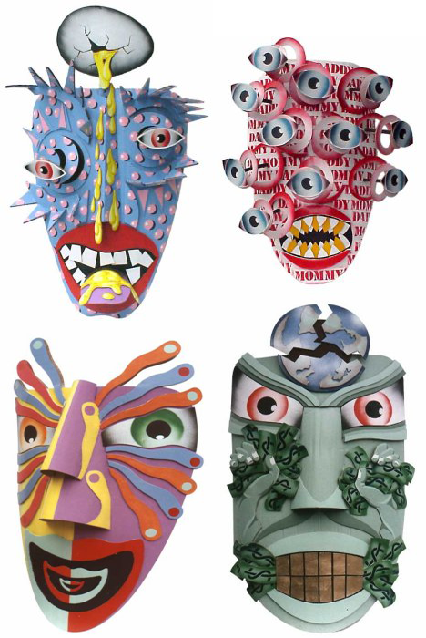
(source: Dag Weiser)
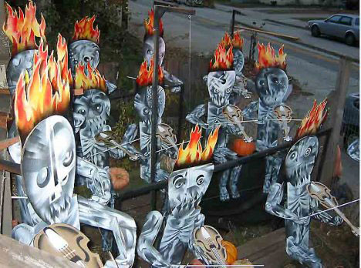
Unlike many of the other artists and sculptors listed here, Dag Weiser doesn’t work exclusively with cardboard. He has works in oil painting on canvas, pastel, ink, bronze, and recycled art from found objects. Weiser’s fascination with cardboard is a relatively recent one. Since he started working with cardboard, however, he has worked on extensive installations and elaborate props and sets. Above is a 1983 installation for a neighborhood Halloween trick-or-treat celebration.

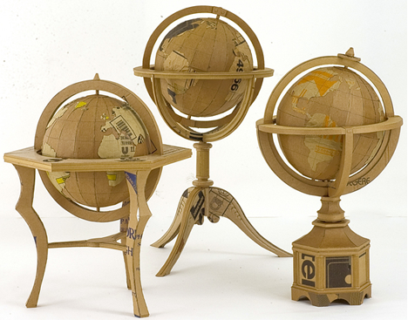
Chris Gilmour
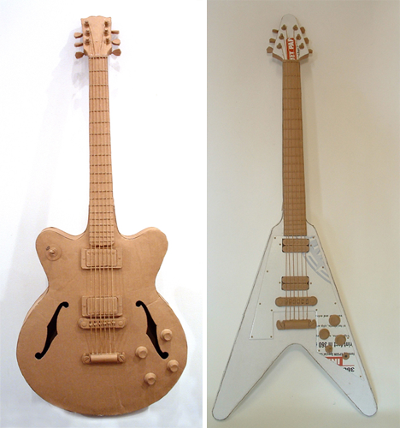
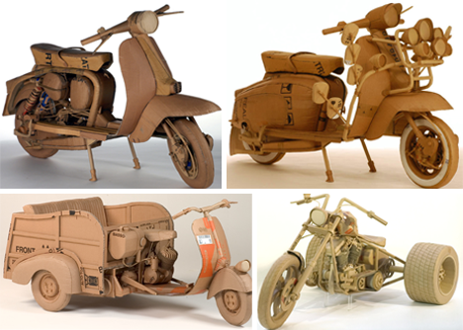

(source: Chris Gilmour)
In contrast to Alex Uribe’s abstract, nature-inspired, organic sculptures, Gilmour’s work is more geometric and usually consists of popular manufactured goods recognizable by the average person. It is also notable that Gilmour uses colored cardboard or paints the final piece to complete the transformation from a piece of cardboard to a finished product.

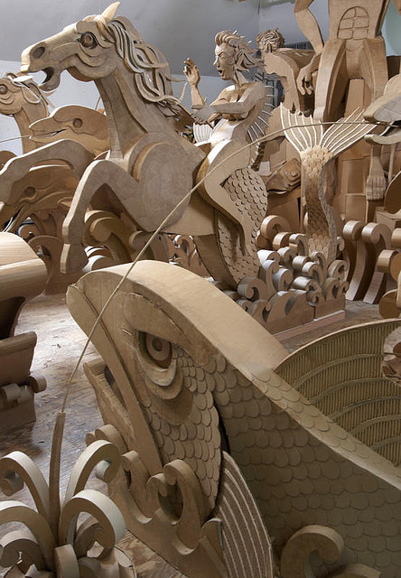
http://www.allthingspaper.net/2014/04/james-grashow-cardboard-art.html

James Grashow: Cardboard Art
I disappeared down a Google-eyed rabbit hole for a good long while this past weekend after hearing about artist James Grashow and The Cardboard Bernini, an award-winning documentary by Olympia Stone.

Grashow constructed an incredible corrugated Baroque fountain interpretation - a Grashow-Bernini, if you will, over a six year period with the intention that it would eventually be left outside in the rain and wind to disintegrate. Sound crazy? Not when you hear his thoughts on the creative process.
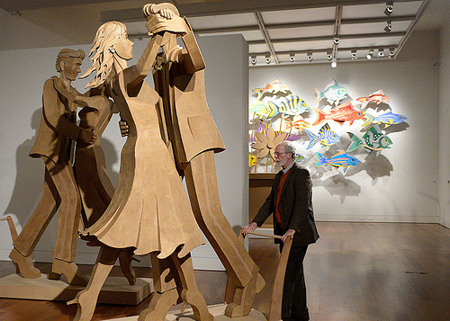
The Cardboard Bernini Trailer from Olympia Stone on Vimeo.
Read this enjoyable New York Times article about the film in which Grashow speaks of cardboard: “It’s so ephemeral,” he said. “It’s so grateful for the opportunity to become something, because it knows it’s going to be trash.”

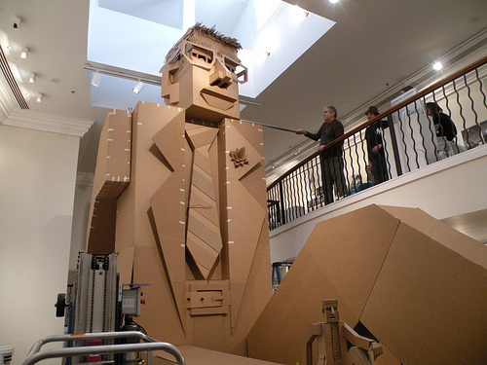
Grashow, a Brooklyn-born sculptor and woodcut artist, has a contagious enthusiasm for the sculptures that he cuts and shapes from cardboard, chipboard, and paper maché. So contagious in fact, I think a trip to Wilmington, North Carolina is in order to see Corrugated World: The Artwork of James Grashow at Cameron Art Museum, on display through August 3. A community art project is involved and what a treat for those who participate... Jimmy, as he is known, is a natural-born teacher.

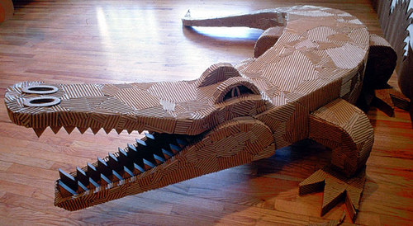
Great Gulliver Project is an example of an installation created with university students, but he does educational cardboard workshops for any age group. "I am convinced there is a link between corrugated board and creativity. Its very valuelessness liberates us. Boxes, tubes, sheets of corrugated board - everything that lives between the good stuff and garbage - becomes a perfect partner for play."

One of Jimmy's early forays into cardboard art was Yazoo - A Corrugated Menagerie, an environmental installation that included alligators, lions, tigers, a giraffe, gorilla, and more for the Aldrich Contemporary Art Museum in Ridgefield, Connecticut.

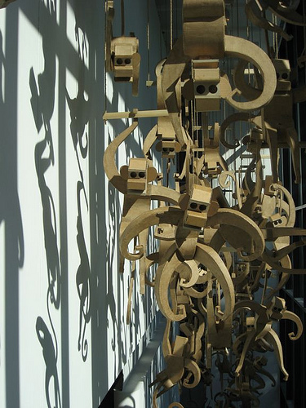
Monkeys with toilet paper roll eyes (as seen in O magazine) went on to multiply and star in their own shows. Here they are in The Great Monkey Project, swinging over a stairwell at the DeCordova Musuem and Sculpture Park in Lincoln, Massachusetts.

Lest you think Grashow doesn't work on a small scale, his series of remarkable flower arrangements, Houseplants, burst forth with intricate structures that depict "the fragile relationship between nature and man."

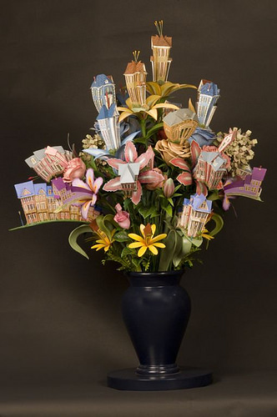
Stunning Cardbirds, inspired by James Audubon prints and made from corrugated cardboard and twist ties, speak to "a unique dimensional vision. The birds and their habitat - timeless and beautiful - are married to the most banal and overlooked of materials."

James Grashow's website and The Cardboard Bernini.

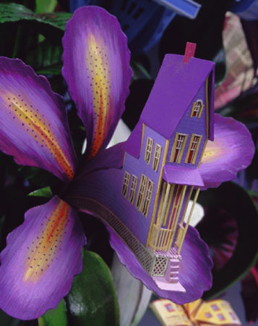
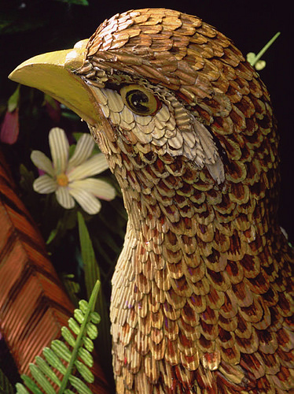

Cardboard Article Questions Name: __________________________Pd:__
(staple to planning sheet)

- Choose one of the artwork examples and explain how using cardboard as the medium relates to the art itself.

- How did artist Mark Langan come to use cardboard as a medium?

- Why do you think artist Chris Gilmour paints his sculptures?

- What does James Grashow say about the value of cardboard, why is he so interested by this?

- Which artwork is your favorite and why?

- What will you incorporate into your own cardboard sculpture from seeing these works?

Cardboard Article Questions Name: __________________________Pd:__
(staple to planning sheet)

- Choose one of the artwork examples and explain how using cardboard as the medium relates to the art itself.

- How did artist Mark Langan come to use cardboard as a medium?

- Why do you think artist Chris Gilmour paints his sculptures?

- What does James Grashow say about the value of cardboard, why is he so interested by this?

- Which artwork is your favorite and why?

- What will you incorporate into your own cardboard sculpture from seeing these works?

