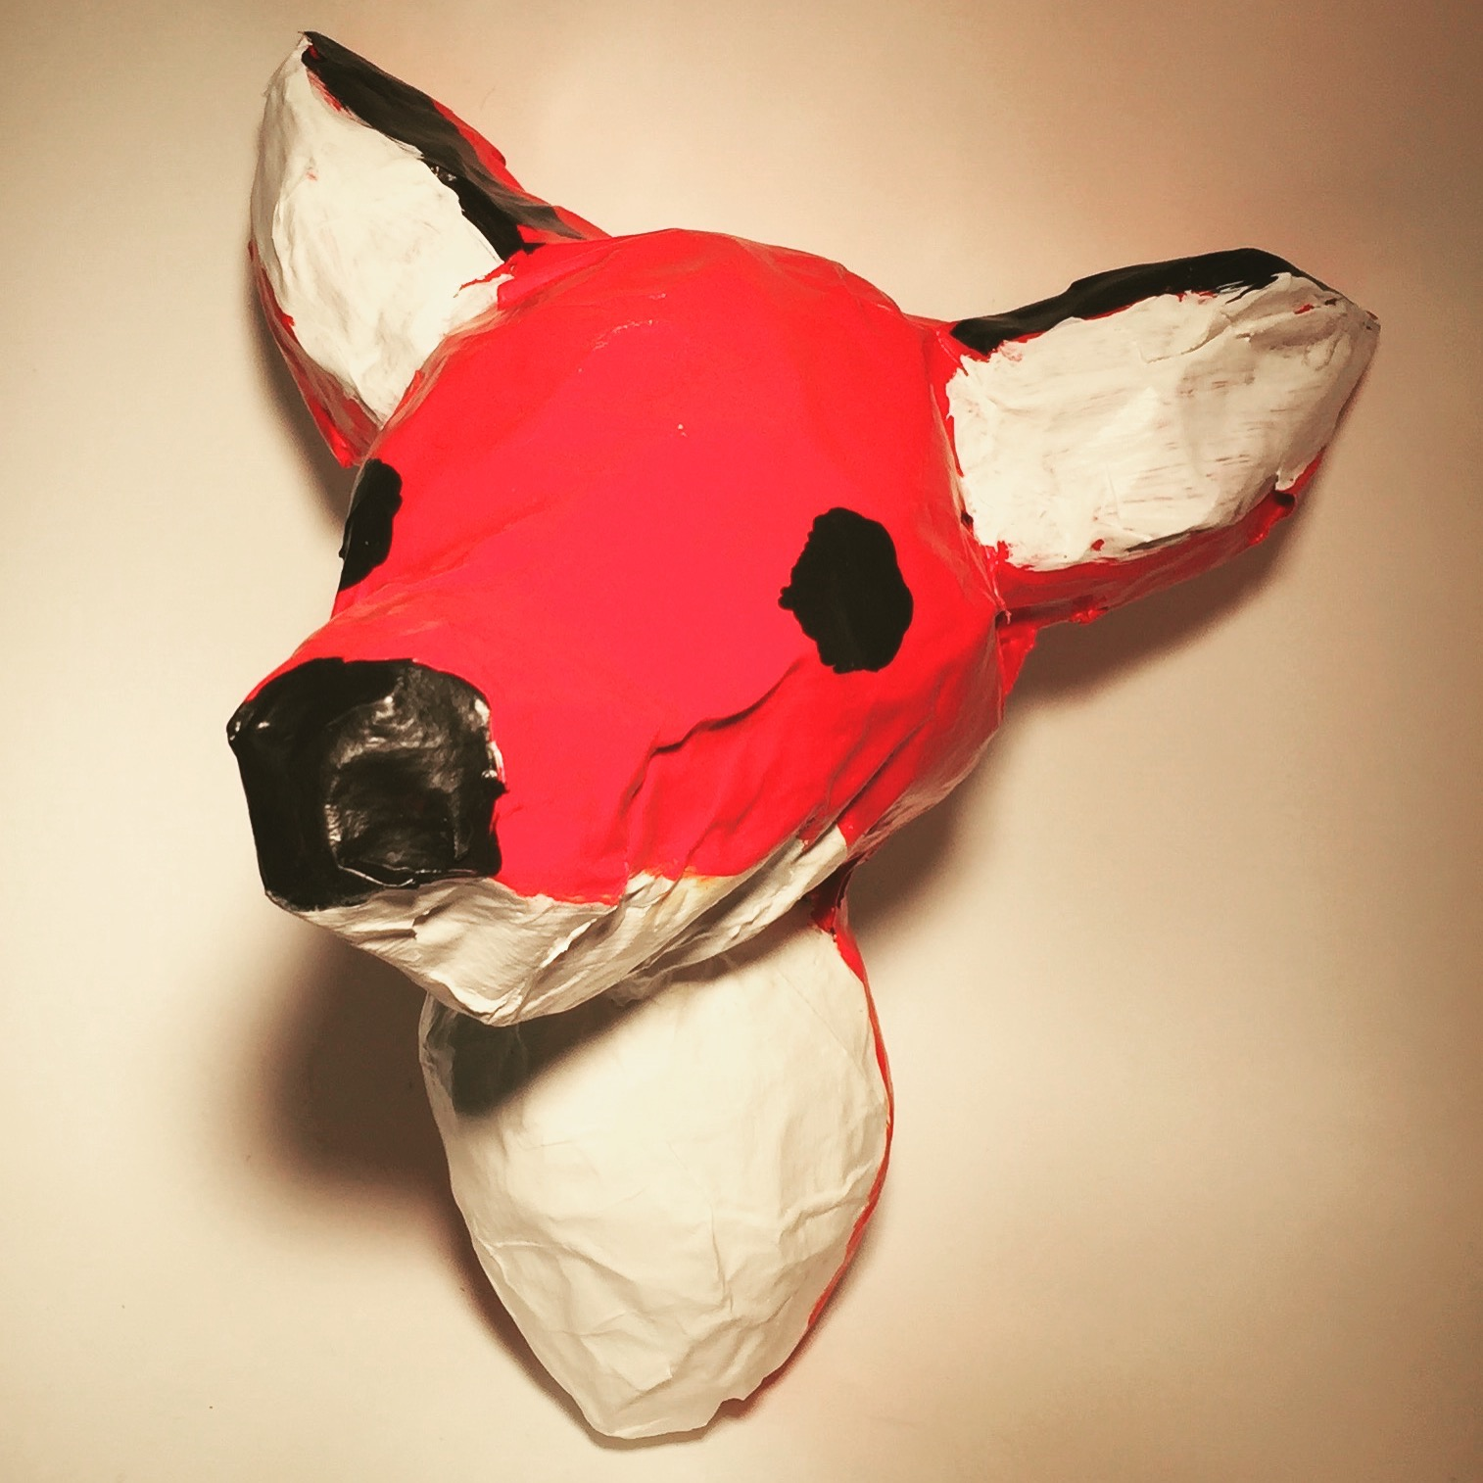
ANIMAL MOUNTS Name: _________________________ Pd: _____
GOALS:
- Some part at least ½ foot out from the wall.
- Accurate Form and Color
- Inclusion of Fine Details
- Flat area for the wall.
- Solid and not squishy

- Brainstorm animals you could choose.
* *
* *
* *
* *
* *
- Narrow your animals to your top three. Choose the one you are most excited about.
1.
2.
3.

3. In your sketchbook! Take your top choice and draw out or print 2 different viewpoints (front and side view) of your chosen animal mount. Are you going to include the neck? Some of the body?

ANIMAL MOUNTS Name: _________________________ Pd: _____
GOALS:
- Some part at least ½ foot out from the wall.
- Accurate Form and Color
- Inclusion of Fine Details
- Flat area for the wall.
- Solid and not squishy

- Brainstorm animals you could choose.
* *
* *
* *
* *
* *
- Narrow your animals to your top three. Choose the one you are most excited about.
1.
2.
3.

3. In your sketchbook! Take your top choice and draw out or print 2 different viewpoints (front and side view) of your chosen animal mount. Are you going to include the neck? Some of the body?

