ANIMAL MOUNTS Name: ____________________________________ Pd: _____
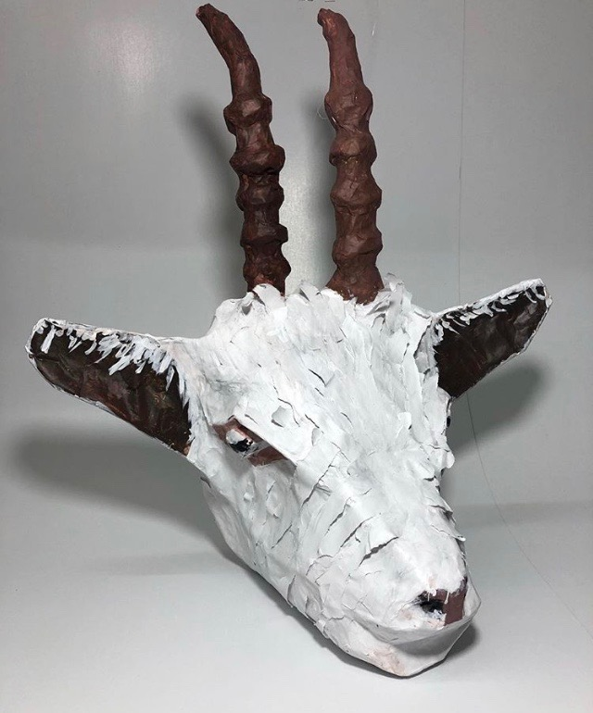
FORM:______________________________________________________
GOALS:
Some part at least ½ foot out from the wall.
Accurate Form and Color
Inclusion of Fine Details
Flat area for the wall.
Solid and not squishy

______________________________________________________________
COLOR:_____________________________________________________
______________________________________________________________
ARMATURE: _______________________________________________
______________________________________________________________

- Brainstorm animals you could choose.
* *
* *
* *
* *
* *

- Narrow your animals to your top three. Choose the one you are most excited about.
1.
2.
3.

3. SKETCHBOOK: Take your top choice and draw out or print 2 different viewpoints (front and side view) of your chosen animal mount. Diagram the flat area and fine details.

ANIMAL MOUNTS Name: ____________________________________ Pd: _____
FORM:______________________________________________________
GOALS:
Some part at least ½ foot out from the wall.
Accurate Form and Color
Inclusion of Fine Details
Flat area for the wall.
Solid and not squishy

______________________________________________________________
COLOR:_____________________________________________________
______________________________________________________________
ARMATURE: _______________________________________________
______________________________________________________________

- Brainstorm animals you could choose.
* *
* *
* *
* *
* *

- Narrow your animals to your top three. Choose the one you are most excited about.
1.
2.
3.

3. SKETCHBOOK: Take your top choice and draw out or print 2 different viewpoints (front and side view) of your chosen animal mount. Diagram the flat area and fine details.

ANIMAL MOUNT GRADING RUBRIC – SCULPTURE 1
YOUR NAME: _______________________________TITLE: ______________________________PERIOD: _____
 | Advanced | Proficient | Basic | In-progress
Goals: Write in goals  9-10  7-8  3-6  1-2 | *1/2 ft out from wall  *Accurate form & color  *Fine details  *Flat area for the wall  *Solid and not squishy (at least 3 layers of paper mache) | Missing 1 goal  Or all goals need a little more attention | Missing 2 or more goals | Goals need to be addressed.
Creativity:  9-10  7-8  3-6  1-2 | Project has extra details or textures. It has an extra element with animal. Developed a new paper mache technique or texture | Idea is more creative than most students’ but could still push idea more. Could have more details that are 3D | Idea seen often and does not have much detail. Only painted on details. Ex: panda with no textures | Copied off of the internet (plagiarism)
Challenge:  5  4-3  2  1 | Chose a difficult animal to create. Spent extra time revising. Many tries to get it right. Used all class time. | Chose normal level of difficulty and typical amount of work. Did requirement of project. | Cut corners, finished early when revisions should be done. Project looks rushed. | Did bare minimum required of the project. Little effort put forth.
Craftsmanship:  9-10  7-8  3-6  1-2 | Techniques executed well, clean paint, High level of details, multiple techniques used, surface is smooth. Form is VERY accurate | Some small sections need more work, some gaps or wrinkles of paper. Paint could be a little cleaner with edges. Form is very close but could be pushed | Very little 3D details or textures. Messy paint. Paper mache is lumpy or wrinkled. Forgotten aspects of animal. More layers of paper mache needed. | Difficult to tell what animal it is. Paint is very messy. Paper mache needs a lot more layers.
Work ethic:  9-10  7-8  3-6  1-2 | Respectful of all routines, procedures people, tools and materials. Cleans up own area and keeps community areas clean. Helps others. | Occasional mess. Finish project early instead of revising.  Needs to improve listening and reading the board. | Cleaned up early and not helping others.  Leaves mess, often not working. Leaving projects incorrect place or cart. Not in assigned seat. | Seen using phone (after clean up counts) Phone not in backpack entire time  Tardy often  Disrespect of tools and others  Project found as ‘litter’ in school.
Artist Statement:  Fill out on back!  5  4-3  2  1 | Complete sentences used and all questions are answered. Insightful reflections written. | Some incomplete sentences used.  But all questions are answered.  Vague answers | One word responses  to questions.  or not all questions are answered. | Student didn’t self-grade  Artist statement left blank.
Grade yourself
________/50

Grade ______/50
Comments to consider:

ANIMAL SCULPTURE GRADING RUBRIC – SCULPTURE 1
ARTIST STATEMENT

- What is your idea behind this project?

- How did you achieve the goals?

- What do you want the viewer to think about?

- What did you change during the process of making this?

- What would you do differently next time?

Animal Mount Sculpture Checklist

Watch presentation about project

Fill out answers to planning sheet a

Draw or print animal in sketchbook

Bring sketchbook and planning to Ms. Mann to see

Make Armature of animal with newspaper, cardboard and tape

Paper Mache 2 layers of newspaper

Paper mache 1 layer of white paper.

Paint animal

Turn in sculpture with grading rubric

